ENERGYWISE – AI BUILDING ENERGY OPTIMIZATION
A PROJECT REPORT
Submitted by
L. M. ANIRUDH KASHYAB
(241501020)
in partial fulfilment of the End Semester Examination for the course
CB23F35 –
LOW-CODE APPLICATION DEVELOPMENT USING ZOHO CREATOR
in
BACHELOR OF TECHNOLOGY
DEPARTMENT OF ARTIFICIAL INTELLIGENCE AND MACHINE LEARNING

RAJALAKSHMI ENGINEERING COLLEGE
(An Autonomous Institution, Affiliated to Anna University, Chennai)
Rajalakshmi Nagar, Thandalam, Tamil Nadu – 602 105
OCTOBER 2026

RAJALAKSHMI ENGINEERING COLLEGE
(An Autonomous Institution, Affiliated to Anna University, Chennai)
BONAFIDE CERTIFICATE
Certified that this project report titled “ENERGYWISE – AI BUILDING ENERGY OPTIMIZATION” is the bonafide work of L. M. ANIRUDH KASHYAB (241501020), who carried out the individual project work on the Zoho Creator low-code platform for CB23F35 – Low-Code Application Development using Zoho Creator, during academic year 2026–2027, Semester V, under the supervision of the course faculty.
SIGNATURE  [Enter current HoD name]  HEAD OF THE DEPARTMENT  Department of Artificial Intelligence and Machine Learning  Rajalakshmi Engineering College  Thandalam – 602 105 | SIGNATURE  [Enter course faculty name]  COURSE FACULTY  [Enter faculty designation]  Department of Artificial Intelligence and Machine Learning  Rajalakshmi Engineering College

Submitted for the End Semester Examination (Individual Project) held on the date notified by the institution.
INTERNAL EXAMINER | EXTERNAL EXAMINER

DECLARATION
L. M. ANIRUDH KASHYAB (241501020), declare that this report for CB23F35 – Low-Code Application Development using Zoho Creator records my individual project work on ENERGYWISE – AI BUILDING ENERGY OPTIMIZATION. I will ensure that the final report accurately distinguishes components I personally implemented from proposed designs, sample code and external resources. Any template, AI-assisted feature, code snippet or external resource used will be acknowledged. I will not claim a feature was implemented or tested unless it is present in the live application and supported by evidence.
I further declare that this work has not been submitted, in part or in full, for the award of any other degree or course credit. Every template, sample application, AI-assisted feature (such as Zia or the AI application builder), code snippet or external resource used in this work has been duly acknowledged in the report.
Place: Chennai SIGNATURE OF THE STUDENT
Date: 19 October 2026 L. M. ANIRUDH KASHYAB
241501020

ACKNOWLEDGEMENT
I express my sincere gratitude to the management of Rajalakshmi Engineering College for providing the academic environment and facilities required to undertake this project.
I am grateful to the Principal of Rajalakshmi Engineering College for encouraging students to undertake application-oriented learning.
I thank the Head of the Department of Artificial Intelligence and Machine Learning for the support provided during the course.
I owe my sincere thanks to the CB23F35 course faculty for guidance and feedback related to the course.
I acknowledge Zoho Corporation for the Zoho Creator platform and its learning resources. I also thank my family and friends for their encouragement.

L. M. ANIRUDH KASHYAB

ABSTRACT
Building operators need a reliable way to record electricity consumption, compare readings across buildings or equipment, and identify unusually high usage. When readings are collected manually or kept in separate spreadsheets, records can be inconsistent, calculations may be repeated, and it can be difficult to obtain a consolidated view of consumption and estimated cost. EnergyWise is designed as an educational prototype for building-energy monitoring using Zoho Creator. It uses sample or manually entered readings unless a real sensor/API integration is separately configured.
The proposed EnergyWise application uses Zoho Creator forms to maintain Building Details and Energy Readings, reports to list and filter records, and a dashboard page to present consumption and estimated cost. A Deluge workflow can calculate cost as energy consumed in kWh multiplied by the rate per kWh and can flag readings that exceed a configurable threshold. Administrator, Energy Manager and Viewer are the intended roles. External APIs, Zoho Catalyst and advanced AI predictions are extension options and must be described as implemented only after they have been configured and tested in the live application.
The project provides a structured design for centralising building and energy-reading data and demonstrates how low-code forms, reports and workflows can reduce repeated manual calculations. The test scenario of 120 kWh at ₹8 per kWh has an expected estimated cost of ₹960. This is a calculated test value, not a measured institutional saving. Live deployment status, measured response times, user feedback and any actual reduction in processing time must be entered after testing the application. The design includes validation, role-based permissions, filtered reports and a staged testing approach.
Keywords: Low-Code Development; Zoho Creator; Energy Management; Deluge Scripting; Workflow Automation; Energy Analytics

PROJECT AT A GLANCE
Attribute | Details
Project Title | ENERGYWISE – AI BUILDING ENERGY OPTIMIZATION
Application Domain | Building energy monitoring and optimisation
Student Name & Register No. | L. M. ANIRUDH KASHYAB – 241501020
Zoho Creator Edition | Account edition to be confirmed in the live account
Application Name (Link Name) | EnergyWise - AI Building Energy Optimization (confirm link name after creation)
Published / Live URL | Not yet confirmed; enter the actual published URL after deployment
Demo Credentials (per role) | Do not include passwords in the report; demonstrate using authorised test accounts
Number of Forms / Subforms | Planned: 2 forms / 0 subforms (confirm actual counts)
Number of Reports (by type) | Planned: list reports and chart/report components (confirm actual counts)
Number of Pages / Dashboards | Planned: 1 Energy Dashboard (confirm actual count)
Number of Workflows | Planned: cost calculation and threshold flag (confirm actual count)
Deluge Functions / Custom Actions | Planned: cost calculation and threshold logic (confirm actual implementation)
Integrations | None confirmed; optional Creator REST API / Catalyst extension
Roles & Profiles Defined | Administrator; Energy Manager; Viewer (design roles; confirm configuration)
Environments Used | Use the environments actually available in the account; deployment not confirmed
Date of Production Deployment | Not deployed / date to be entered after deployment

TABLE OF CONTENTS
Formatting Standards (Anna University Convention) 1
Working with the Template 1
ABSTRACT iv
PROJECT AT A GLANCE v
LIST OF TABLES ix
LIST OF FIGURES x
LIST OF ABBREVIATIONS xi
INTRODUCTION 1
1.1 Background 1
1.2 Problem Statement 1
1.3 Objectives 1
1.4 Scope of the Project 1
1.5 Justification for a Low-Code Approach 2
1.6 Organisation of the Report 2
LITERATURE SURVEY AND SYSTEM STUDY 3
2.1 Study of the Existing System 3
2.2 Limitations of the Existing System 3
2.3 Low-Code versus Traditional Development 3
2.4 Literature Survey 4
2.5 Emerging Trends in Low-Code Development 4
2.6 Proposed System 4
REQUIREMENT ANALYSIS 5
3.1 Stakeholders and User Roles 5
3.2 Functional Requirements 5
3.3 Non-Functional Requirements 5
3.4 Hardware and Software Requirements 6
3.5 Use Case Model 6
SYSTEM DESIGN 8
4.1 System Architecture 8
4.2 Data Model 8
4.3 Form Design 9
4.4 Process and Workflow Design 9
4.5 User Interface and Navigation Design 10
4.6 Access Control Design 10
IMPLEMENTATION 11
5.1 Application Setup 11
5.2 Forms and Data Capture 11
5.3 Reports 12
5.4 Pages and Dashboards 13
5.5 Deluge Scripting 13
5.6 Workflows and Automation 14
5.7 Integrations 15
5.8 User Management and Role-Based Access 16
5.9 AI and Analytics Features 16
5.10 Pro-Code Extension 17
5.11 Mobile and Portal Access 17
TESTING AND DEBUGGING 18
6.1 Testing Strategy 18
6.2 Test Cases 18
6.3 Debugging Deluge Scripts 18
6.4 Defect Log 19
6.5 User Acceptance Testing 19
DEPLOYMENT, SECURITY AND GOVERNANCE 20
7.1 Environments and Deployment Strategy 20
7.2 Performance Optimisation 20
7.3 Security Features 21
7.4 Governance and Administration 21
RESULTS AND DISCUSSION 22
8.1 Application Output 22
8.2 Achievement of Objectives 23
8.3 Comparison with the Existing System 23
8.4 Limitations of the Low-Code Approach 23
8.5 Reflection on the No-Code → Low-Code → Pro-Code Spectrum 23
CONCLUSION AND FUTURE ENHANCEMENTS 24
9.1 Conclusion 24
9.2 Future Enhancements 24
9.3 Learning Outcomes and Career Relevance 24
REFERENCES 25
APPENDIX A – ZOHO CREATOR FEATURE COVERAGE CHECKLIST 26
APPENDIX B – COURSE OUTCOME MAPPING 28
APPENDIX C – COMPLETE DELUGE SOURCE CODE 29
APPENDIX D – USER MANUAL 30
D.1 Accessing the Application 30
D.2 Instructions for [Role 1] 30
D.3 Instructions for [Role 2] 30
APPENDIX E – EVALUATION RUBRIC 31
APPENDIX F – VIVA-VOCE RECORD SHEET 33

LIST OF TABLES
Table 2.1: Comparison of Low-Code and Traditional Development for the Proposed Application 3
Table 2.2: Summary of Literature Survey 4
Table 3.1: Stakeholders and User Roles 5
Table 3.2: Functional Requirements 5
Table 3.3: Non-Functional Requirements 5
Table 3.4: Hardware and Software Requirements 6
Table 3.5: Use Case Description – [Use Case Name] 6
Table 4.1: Entities and Relationships 9
Table 4.2: Field Specification – [Form Name] Form 9
Table 4.3: Role–Permission Matrix 10
Table 5.1: Reports Implemented 12
Table 5.2: Deluge Scripts Implemented 13
Table 5.3: Workflows Implemented 14
Table 5.4: Integrations Implemented 15
Table 6.1: Test Cases 18
Table 6.2: Defect Log 19
Table 6.3: User Acceptance Feedback 19
Table 7.1: Deployment Checklist 20
Table 7.2: Performance Optimisation Results 20
Table 7.3: Security Controls Implemented 21
Table 8.1: Mapping of Objectives to Outcomes 23
Table 8.2: Existing System versus Proposed Application 23
Table A.1: Feature Coverage Checklist 26
Table B.1: Mapping of Course Outcomes to Report Chapters 28
Table E.1: Evaluation Rubric for the Individual Project 31
Table E.2: Performance Level Descriptors 32
Table F.1: Viva-Voce Questions and Responses 33
Table F.2: Marks Summary 33

LIST OF FIGURES
Figure 2.1: [As-Is Process Flow of the Existing System] 3
Figure 3.1: [Use Case Diagram of the Application] 6
Figure 4.1: [System Architecture of the Application] 8
Figure 4.2: [Entity–Relationship Diagram] 8
Figure 4.3: Workflow / Process Flow for [Process Name] 10
Figure 4.4: Navigation Structure and Wireframe of [Page Name] 10
Figure 5.1: [Application Home and Navigation Sections] 11
Figure 5.2: [Form Name] Form in the Form Builder 11
Figure 5.3: [Form Name] Form in Live Mode 12
Figure 5.4: [Report Name] Report 12
Figure 5.5: [Dashboard Page Name] 13
Figure 5.6: [Workflow / Blueprint] Configuration 15
Figure 5.7: [Connection Setup and Postman / Response Output] 16
Figure 5.8: [Roles and Permission Profiles Configuration] 16
Figure 5.9: [AI / Analytics Feature in Use] 17
Figure 5.10: [Application on Mobile / Customer Portal] 17
Figure 6.1: [Deluge Debug Output / Log] 19
Figure 7.1: [Environments / Publish to Production] 20
Figure 7.2: [Audit Trail / Administration Settings] 21
Figure 8.1: Scenario Step 1 – [Description] 22
Figure 8.2: Scenario Step 2 – [Description] 22
Figure 8.3: Scenario Step 3 – [Description] 22

LIST OF ABBREVIATIONS
Abbreviation | Expansion
AI | Artificial Intelligence
API | Application Programming Interface
CRUD | Create, Read, Update, Delete
ER | Entity–Relationship
IoT | Internet of Things
kWh | Kilowatt-hour
LCAP | Low-Code Application Platform
RBAC | Role-Based Access Control
REST | Representational State Transfer
UI | User Interface
UAT | User Acceptance Testing
Zia | Zoho AI assistant
Zia | Zoho’s AI assistant
Not used / verify | Not used / verify

CHAPTER 1

INTRODUCTION

1.1 Background
EnergyWise – AI Building Energy Optimization is an academic prototype in the building-energy management domain. It is intended for a campus, office or other building operator who needs to maintain building information and monitor electricity readings. The application is designed for a small-to-medium set of buildings and readings entered by an authorised user or imported through a future integration. The workflow begins with registering a building, recording an energy reading, reviewing consumption and estimated cost, and identifying readings that may require investigation. No live building-management system or physical sensor is assumed unless separately connected.

1.2 Problem Statement
Energy consumption data can be difficult to monitor when building details, meter readings, equipment information and cost calculations are stored in separate records or spreadsheets. EnergyWise proposes a centralised Zoho Creator application to capture building and energy data, calculate estimated electricity cost, display reports and highlight readings that cross a configurable threshold. The prototype supports decision-making from recorded data; it does not by itself control HVAC equipment or guarantee energy savings.
- Energy readings may be stored in separate spreadsheets, making consolidated review difficult.
- Manual cost calculations and inconsistent field formats can lead to avoidable errors.
- Without filtered reports and threshold alerts, unusual consumption may be noticed late.

1.3 Objectives
- To design linked forms for building details and energy readings.
- To automate estimated electricity-cost calculation and threshold-based review flags, where configured.
- To provide reports and a dashboard for building-wise energy consumption and estimated cost.
- To evaluate secure API integration for importing energy readings; integration is optional and must be reported only if implemented.
- To deploy the application securely to a production environment with governance controls.

1.4 Scope of the Project
In scope: building registration; energy-reading entry; equipment category; date, kWh and tariff fields; estimated cost calculation; reports and a dashboard; configurable threshold-based flags; role and permission design; test cases and documentation. Out of scope for the initial prototype: direct control of building equipment, guaranteed energy savings, production-grade IoT ingestion, billing-system integration, and a trained forecasting model unless separately implemented. Intended roles are Administrator, Energy Manager and Viewer. Web access is the primary channel; mobile access is optional and must be verified.

1.5 Justification for a Low-Code Approach
Zoho Creator is suitable for a prototype because visual form design, report creation and workflow configuration can be completed without writing a separate frontend and backend for every feature. Deluge can implement simple business rules, while Creator provides application hosting and access-control options. This lowers the initial development burden and allows fields and reports to be adjusted as requirements become clearer. Platform limits, plan-dependent features and advanced AI or sensor integration remain considerations [1], [2].

1.6 Organisation of the Report
Chapter 2 reviews the existing system and related low-code literature. Chapter 3 presents the requirement analysis. Chapter 4 describes the system design. Chapter 5 details the implementation on Zoho Creator. Chapter 6 covers testing and debugging. Chapter 7 discusses deployment, performance optimisation, security and governance. Chapter 8 presents results and discussion, and Chapter 9 concludes the report with future enhancements.
CHAPTER 2

LITERATURE SURVEY AND SYSTEM STUDY

2.1 Study of the Existing System
For the case study, the baseline process is assumed to be a manual or spreadsheet-based workflow: an operator reads a meter or receives a reading, enters it into a spreadsheet, calculates cost using a tariff, compares it with earlier readings, and prepares a summary for a supervisor. This is a representative problem scenario for the project, not a claim that a specific campus currently follows this exact process.
2.2 Limitations of the Existing System
- Scattered records make it harder to obtain a consolidated view of energy use.
- Repeated manual calculations can introduce errors and consume staff time.
- Manual review provides limited automatic highlighting of unusual readings.

2.3 Low-Code versus Traditional Development
Table 2.1: Comparison of Low-Code and Traditional Development for the Proposed Application
Criterion | Traditional (Pro-Code) Development | Low-Code on Zoho Creator
Development time | Requires separate UI, backend, database and deployment work; effort depends on scope. | Visual forms, reports and workflows can shorten the prototype cycle; actual time must be measured.
Skills required | Programming, frontend/backend, database, hosting and testing. | Platform knowledge, data modelling and Deluge for custom logic.
Hosting & infrastructure | Must be selected, configured and maintained. | Hosting is provided as part of the Creator service, subject to plan.
Mobile application | Usually requires responsive UI or separate mobile work. | Creator mobile access may be available; test on the actual account/device.
Security & access control | Custom authentication and authorisation must be implemented and maintained. | Built-in access controls can be configured; correctness still requires testing.
Maintenance & change | Changes may require code changes and redeployment. | Many form/report changes can be made visually; complex changes still need testing.
Customisation limits | High flexibility with sufficient engineering effort. | Bound by Creator components, Deluge capabilities and plan limits.
Cost | Development and hosting costs depend on stack and team. | Subscription/plan and usage costs apply; verify the actual account plan.

2.4 Literature Survey
Table 2.2: Summary of Literature Survey
S.No. | Author(s) / Source & Year | Title / Product | Key Findings | Relevance to this Project
1 | Zoho Corporation, n.d. | Zoho Creator Help Documentation | Explains application, form, report, page and workflow capabilities. | Primary platform reference for the EnergyWise design [1].
2 | Zoho Corporation, n.d. | Deluge Documentation | Documents scripting syntax and built-in functions for application logic. | Supports the proposed cost and threshold workflow [2].
3 | Zoho Corporation, n.d. | Zoho Catalyst Documentation | Describes services for extending applications with custom code and APIs. | Provides a possible future pro-code extension [3].
4 | International Organization for Standardization, 2018 | ISO 50001:2018 Energy management systems | Provides a framework for establishing and improving energy-management systems. | Motivates structured energy data, monitoring and continual improvement [4].
5 | U.S. Department of Energy, n.d. | Energy management / building energy information resources | Provides practical resources for managing building energy use and improving efficiency. | Provides domain context for monitoring consumption and investigating unusual readings [5].

2.5 Emerging Trends in Low-Code Development
Relevant low-code trends include visual application building, citizen development, workflow automation, reusable integrations and AI-assisted analytics. EnergyWise applies visual forms and reports for the core data workflow. Deluge can automate deterministic calculations, while APIs can support future connection to external meter systems. AI-assisted features should be used only if they are available in the account and their outputs can be validated. The current design does not claim that a trained AI model is already deployed.

2.6 Proposed System
EnergyWise proposes two related data forms: Building Details and Energy Readings. A building can have many readings, represented through a lookup field from Energy Readings to Building Details. Reports provide searchable reading lists and building-wise summaries, A workflow can calculate cost and flag readings above a configured threshold. The implementation status of each component must be checked against the live Creator application before final submission.
CHAPTER 3

REQUIREMENT ANALYSIS

3.1 Stakeholders and User Roles
Table 3.1: Stakeholders and User Roles
Role | Description | Key Responsibilities in the Application
Administrator | Maintains the application and its configuration. | Manage forms, workflows, permissions and all authorised records.
Energy Manager | Reviews building energy performance. | Create/update readings as permitted; review reports and investigate flagged readings.
Viewer | Read-only user of permitted energy information. | View authorised reports and dashboard; no record editing.
Viewer | Not used / verify | View permitted energy reports

3.2 Functional Requirements
Table 3.2: Functional Requirements
FR ID | Requirement | Role(s) | Priority
FR-01 | The system shall allow an authorised user to create a building record with building name, ID, location, floors and area. | Administrator, Energy Manager | High
FR-02 | The system shall allow an authorised user to record a dated energy reading linked to a building. | Administrator, Energy Manager | High
FR-03 | The system shall calculate estimated energy cost as kWh multiplied by the tariff when the workflow is configured. | Administrator, Energy Manager | High
FR-04 | The system shall identify readings above a configurable review threshold. | Energy Manager | Medium
FR-05 | The system shall display searchable energy records and consumption summaries. | Administrator, Energy Manager, Viewer | High
FR-06 | The system shall restrict record actions according to configured roles and permissions. | All roles | High
FR-07 | The system may import readings through an authenticated API if integration is implemented. | Administrator / Integration service | Low
FR-08 | The system shall allow filtering by building, date and equipment type where configured. | Administrator, Energy Manager, Viewer | Medium

3.3 Non-Functional Requirements
Table 3.3: Non-Functional Requirements
NFR ID | Category | Requirement
NFR-01 | Performance | Reports should remain responsive for the expected academic prototype dataset; record actual timings during testing.
NFR-02 | Security | Users shall access only the forms, records and reports permitted by their configured role.
NFR-03 | Usability | Forms should use clear labels, suitable field types and understandable validation messages.
NFR-04 | Availability | Application availability depends on Zoho Creator service availability and account access.
NFR-05 | Maintainability | Forms, fields, reports and workflows shall use consistent names and documented logic.
NFR-06 | Auditability | Use available record history/audit features where enabled; document any plan limitations.

3.4 Hardware and Software Requirements
Table 3.4: Hardware and Software Requirements
Category | Specification
Platform | Zoho Creator; exact edition to be confirmed in account settings
Scripting language | Deluge, if workflow scripting is configured
Browser | Recent Google Chrome, Microsoft Edge or Mozilla Firefox
API testing tool | Postman, optional if API integration is implemented
Other Zoho services | Zoho Catalyst is a proposed optional extension, not a confirmed integration
Mobile | Zoho Creator mobile app, optional and subject to testing
Client hardware | Computer with a modern browser and reliable internet connection

3.5 Use Case Description – Register Building
Use Case ID | UC-01
Use Case Name | Register Building
Actor(s) | Administrator / Energy Manager
Pre-condition | User is signed in and has permission to add building records.
Main Flow | 1. Open Building Details. 2. Enter building information. 3. Submit the form. 4. System validates required fields and saves the record.
Alternate Flow | If required data is missing or invalid, the form displays validation feedback.
Post-condition | Building record is stored and can be selected for energy readings.
Related FR | FR-01
CHAPTER 4

SYSTEM DESIGN

4.1 System Architecture
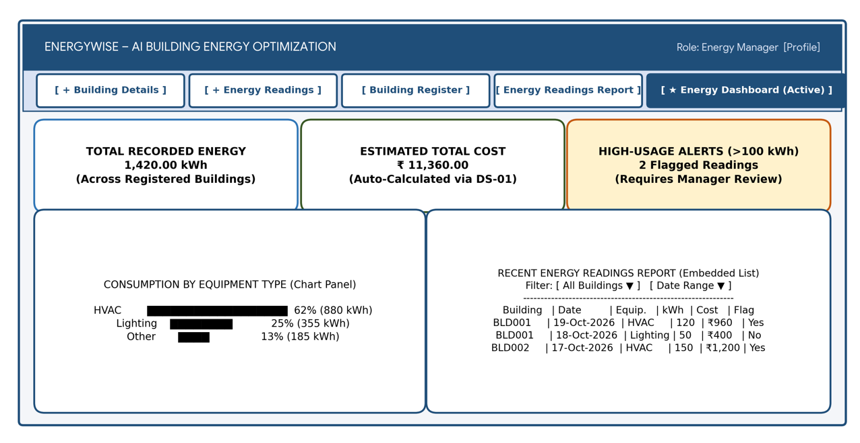
Figure 4.1: Proposed System Architecture of EnergyWise
The proposed architecture has four layers. Users access the application through the Zoho Creator web interface (and mobile access if enabled). The application layer contains forms, reports, a dashboard page and Deluge workflows. The data layer stores building and energy-reading records, linked through a lookup field. An optional integration layer can import readings through an authenticated API or process advanced analytics through a separate service. The optional integration layer is a future extension unless configured and tested.

4.2 Data Model
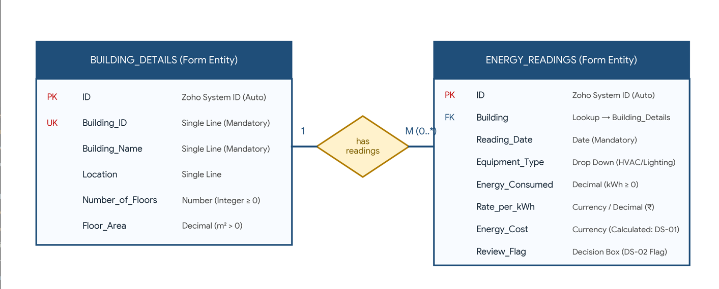
Figure 4.2: Entity–Relationship Diagram of EnergyWise
Table 4.1: Entities and Relationships
Entity (Form) | Key Fields | Related To | Relationship Type | Implemented Using
Building Details | Building_ID, Building_Name, Location, Floors, Floor_Area | Energy Readings | One-to-Many | Lookup from Energy Readings to Building Details
Energy Readings | Building, Reading_Date, Equipment_Type, Energy_Consumed, Rate_per_kWh, Energy_Cost | Building Details | Many readings to one building | Lookup field; verify actual link name
Optional Alert/Recommendation | Reading reference, flag reason, review status | Energy Readings | Optional one-to-many | Separate form only if implemented

4.3 Form Design
Table 4.2: Field Specification – Building Details and Energy Readings Forms
Field Label | Link Name | Field Type | Mandatory | Validation / Default | Remarks
Building ID | Building_ID | Single Line or Auto Number | Yes | Unique identifier; configure no-duplicate validation if available | Use actual link name from Creator
Building Name | Building_Name | Single Line | Yes | Cannot be blank | Building display name
Location | Location | Single Line | No | — | Building location
Number of Floors | Number_of_Floors | Number | No | Non-negative integer | Number of floors
Floor Area (m²) | Floor_Area | Decimal | No | Greater than zero if supplied | Area in square metres
Building | Building | Lookup | Yes | Select a valid Building Details record | Energy Readings relationship
Reading Date | Reading_Date | Date | Yes | Valid date | Date of reading
Equipment Type | Equipment_Type | Drop Down | Yes | HVAC; Lighting; Other | Options to configure
Energy Consumed (kWh) | Energy_Consumed | Decimal | Yes | Must be zero or greater | Reading quantity
Rate per kWh | Rate_per_kWh | Currency or Decimal | Yes | Must be zero or greater | Tariff in ₹/kWh
Energy Cost | Energy_Cost | Currency or Decimal | No | Calculate from kWh × rate | Populate through formula/workflow if configured

4.4 Process and Workflow Design
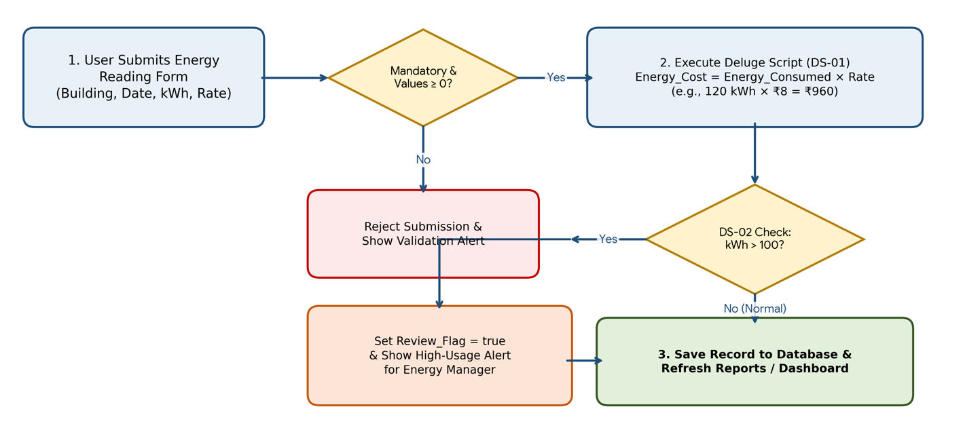
Figure 4.3: Workflow for Energy Cost Calculation and High-Usage Review

4.5 User Interface and Navigation Design

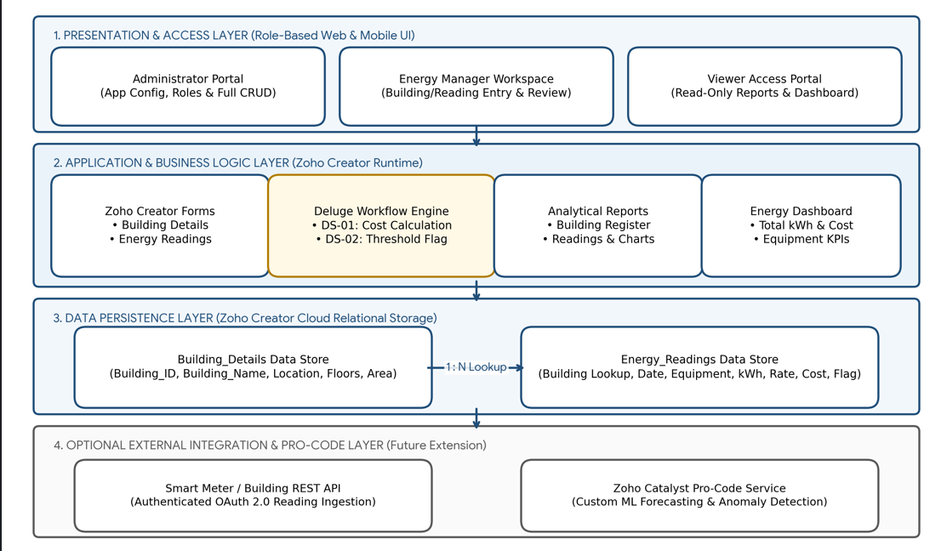

Figure 4.4: Navigation Structure of the Energy Dashboard

4.6 Access Control Design
Table 4.3: Role–Permission Matrix
Component | Administrator | Energy Manager | Viewer | Viewer
Form: Building Details | A E V D | A E V | V | —
Form: Energy Readings | A E V D | A E V | V | A V (own)
Report: Energy Readings | V | V | V | —
Page: Energy Dashboard | V | V | V | —
Not used / verify | Not used / verify | Not used / verify | Not used / verify | Not used / verify
CHAPTER 5

IMPLEMENTATION

5.1 Application Setup
The application is intended to be created as a separate Zoho Creator application named “EnergyWise - AI Building Energy Optimization”. The existing applications visible in the account dashboard should remain unchanged. The application menu should expose Building Details, Energy Readings, their reports and the Energy Dashboard. The exact link name, theme and creation date should be copied from the live application after it is created.
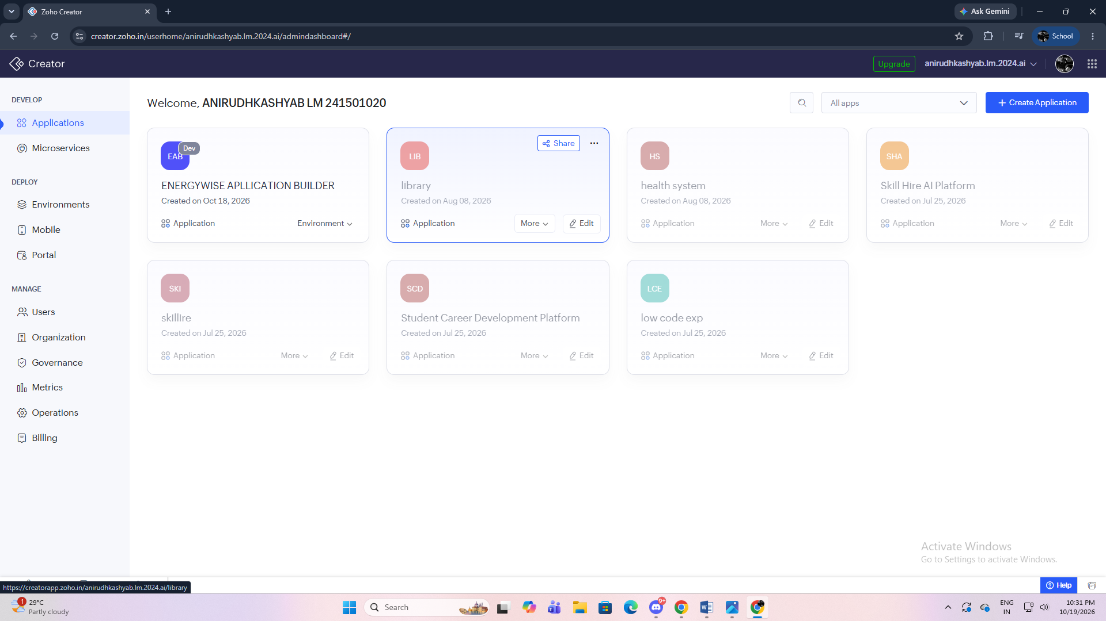
Figure 5.1: EnergyWise Application Home and Navigation (insert live screenshot)

5.2 Forms and Data Capture
Building Details stores Building Name, Building ID, Location, Number of Floors and Floor Area (m²). Energy Readings stores a lookup to Building Details, Reading Date, Equipment Type, Energy Consumed (kWh), Rate per kWh and Energy Cost. Required fields should be marked mandatory and numeric fields should reject negative values where suitable. The Energy Cost field may be populated by a workflow or formula, depending on the final implementation. Field link names in the live app must be checked before using Deluge code.
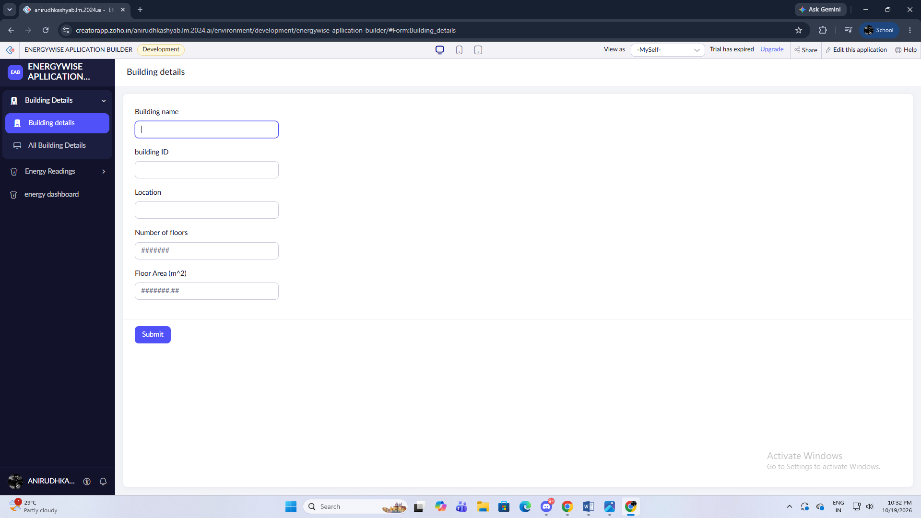
Figure 5.2: Building Details Form Builder (insert live screenshot)

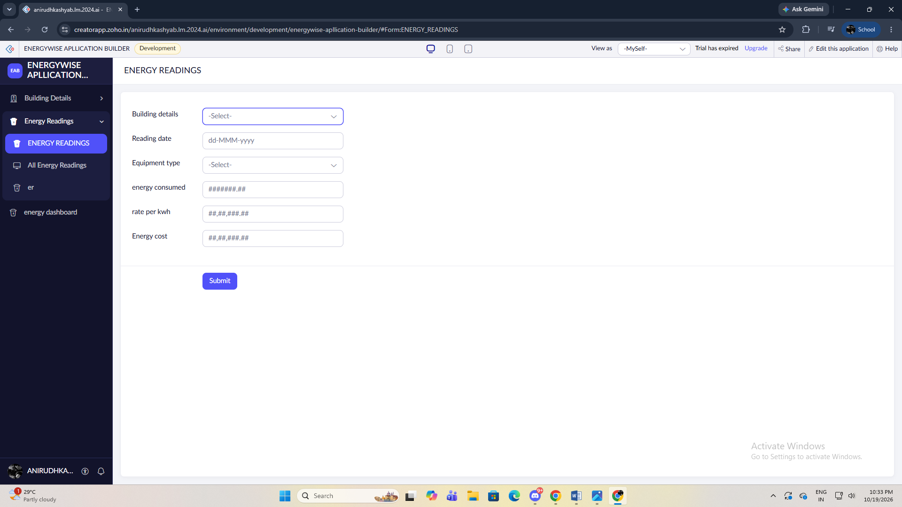Figure 5.3: Energy Readings Form in Live Mode (insert live screenshot)

5.3 Reports
Table 5.1: Reports Implemented
Report Name | Type | Source Form | Filter / Grouping / Sorting | Custom Actions | Roles
Building Register | List | Building Details | Sort by Building Name | None planned | Administrator, Energy Manager
Energy Readings Report | List | Energy Readings | Filter by building/date; sort date descending | None planned | Administrator, Energy Manager, Viewer
Consumption by Equipment | Chart / summary | Energy Readings | Group by Equipment Type; aggregate kWh | None planned | Administrator, Energy Manager, Viewer
Energy Dashboard | Page with embedded reports/KPIs | Energy Readings | Total kWh, estimated cost and trend chart if configured | Navigation links | Administrator, Energy Manager, Viewer
Not used / verify | Chart / summary | Not used / verify | Not used / verify | Not used / verify | Not used / verify

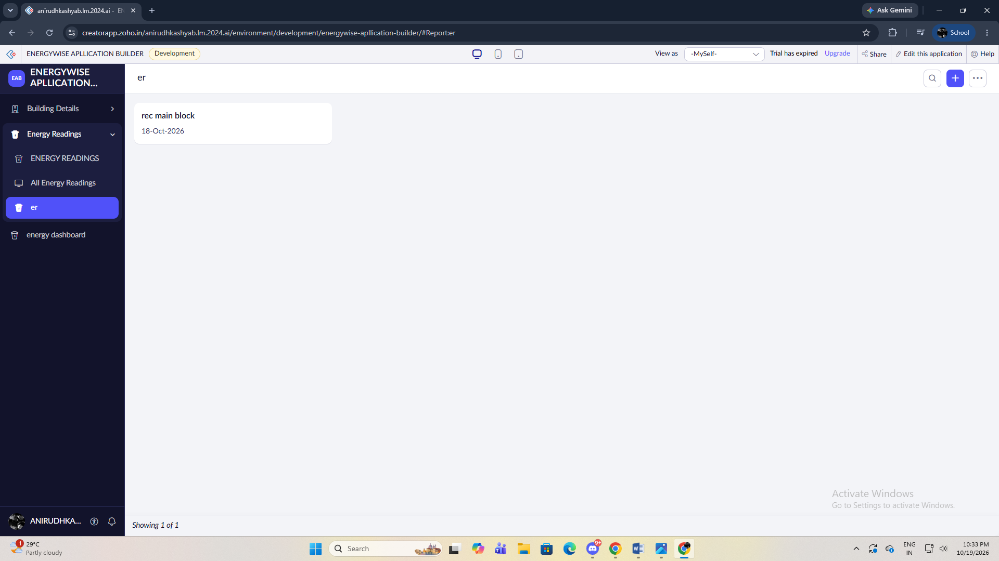Figure 5.4: Energy Readings Report (insert live screenshot)

5.4 Pages and Dashboards
The planned Energy Dashboard is intended for the Energy Manager and Administrator. It may include KPI panels for total recorded energy and estimated cost, a chart of consumption by date or equipment type, and an embedded Energy Readings report. Components and totals should be included only when configured in the live page builder. The Viewer role should receive read-only access to permitted reports.

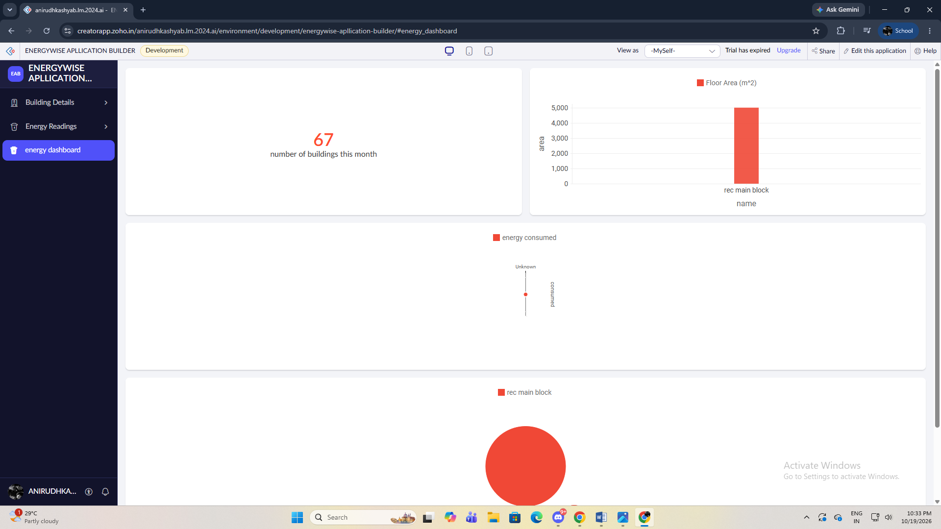Figure 5.5: Energy Dashboard (insert live screenshot)

5.5 Deluge Scripting
Table 5.2: Deluge Scripts Implemented
Script ID | Location / Trigger | Purpose | Deluge Concepts Used
DS-01 | Energy Readings → On Success or suitable workflow event (configure in app) | Calculate Energy_Cost = Energy_Consumed × Rate_per_kWh | Field access, arithmetic, assignment
DS-02 | Energy Readings → workflow after validation (optional) | Flag readings exceeding the configured review threshold | if condition, comparison, field update
Not planned | Energy cost / threshold logic | Calculate cost or flag high usage | Arithmetic, if-condition
Not applicable | Not used in initial design | Not applicable to energy monitoring | Not applicable
Not used / verify | Not used / verify | Not used / verify | Not used / verify

Code 5.1: Energy Cost Calculation (verify actual field link names)
Deluge example – adapt after checking the actual field link names
// DS-01: illustrative calculation only; verify link names and workflow event before use
input.Energy_Cost = input.Energy_Consumed * input.Rate_per_kWh;
// Expected test: 120 kWh × ₹8/kWh = ₹960
// Add validation for non-negative values through field validation or workflow as appropriate.

Code 5.2: Optional High-Usage Review Flag
// DS-02: illustrative threshold logic; create the destination field before enabling
// if(input.Energy_Consumed > 100)
// {
// input.Review_Flag = true;
// }
// The threshold of 100 kWh is a demonstration setting and should be calibrated to the building.

The proposed DS-01 calculation multiplies Energy Consumed (kWh) by Rate per kWh and writes the result to Energy Cost. For the test input 120 kWh and ₹8/kWh, the expected result is ₹960. A second rule may flag a reading above a configurable threshold (for example, 100 kWh per record) for review. The threshold is a demonstration value, not a universal definition of excessive use. Confirm the actual field link names and workflow event before enabling the script.

5.6 Workflows and Automation
Table 5.3: Workflows Implemented
Workflow Name | Type | Trigger / Event | Condition | Action(s) | Script Ref.
Energy Cost Calculation | Form workflow | After valid reading submission | Energy and tariff values are present | Calculate and store estimated cost | DS-01
High Usage Review Flag | Form workflow (optional) | After reading submission | Energy_Consumed exceeds configured threshold | Set review flag or show message | DS-02
Energy Reading Review | Not planned | Not applicable | Not used / verify | Not used / verify | Not used / verify
Not planned | Not planned | Not applicable | Not applicable | Not applicable | Not applicable
Not used / verify | Not used / verify | Not used / verify | Not used / verify | Not used / verify | Not used / verify

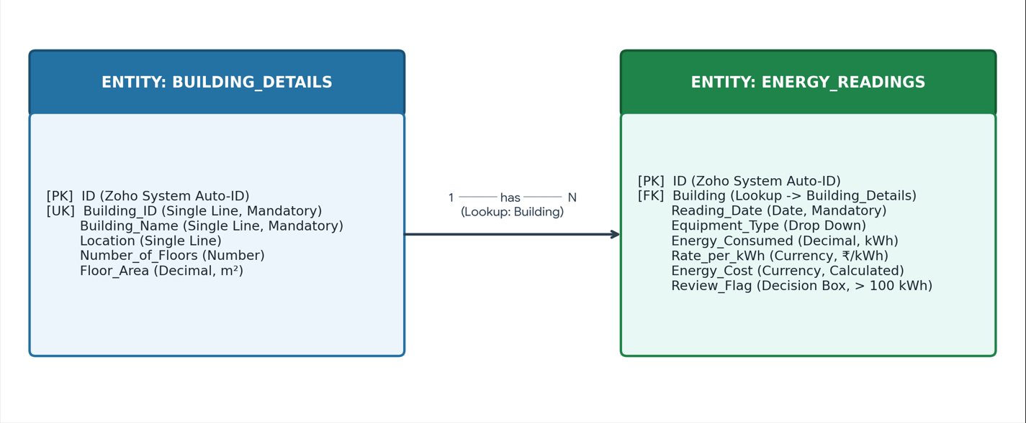
Figure 5.6: Energy Workflow Configuration (insert live screenshot if implemented)

5.7 Integrations
Table 5.4: Integrations Implemented
Integration | Service / Endpoint | Method | Authentication | Data Exchanged / Purpose
Current prototype | No external integration confirmed | Not applicable | Not applicable | Readings are expected to be entered manually until an integration is implemented.
Future sensor/API integration | Authorised meter API or Creator REST API | HTTPS REST request | OAuth / secure connection as supported | Import readings; configure only after endpoint and credentials are available.
Future pro-code extension | Zoho Catalyst or equivalent | HTTPS API | Secure connection / OAuth as applicable | Optional advanced processing or ML inference.

Code 5.3: Optional API Integration Pseudocode (not executable until configured)
Illustrative pseudocode only – do not execute until a real endpoint and secured connection are configured
// response = invokeurl
// [
// url : "https://your-authorised-endpoint.example/readings"
// type : GET
// connection : "your_secure_connection_link_name"
// ];
// info response;
// Never paste access tokens or API secrets into the report.

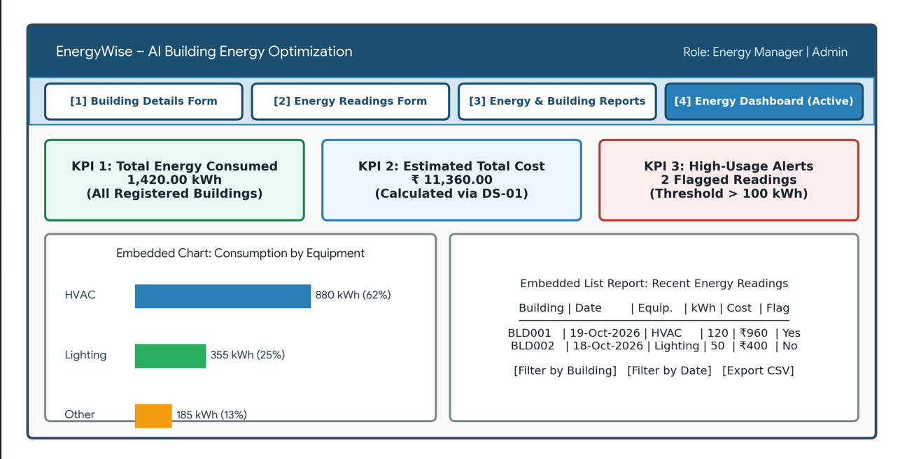Figure 5.7: API Connection and Response (only if implemented)

5.8 User Management and Role-Based Access
The intended role model contains Administrator, Energy Manager and Viewer. The Administrator maintains application configuration and has broad access. The Energy Manager creates and edits building/reading records and views reports. The Viewer can view approved reports but should not create, edit or delete records. These are design intentions; record-level and report permissions must be configured and verified in the live application. Do not claim a role has been tested until an actual test login or permission test is performed.

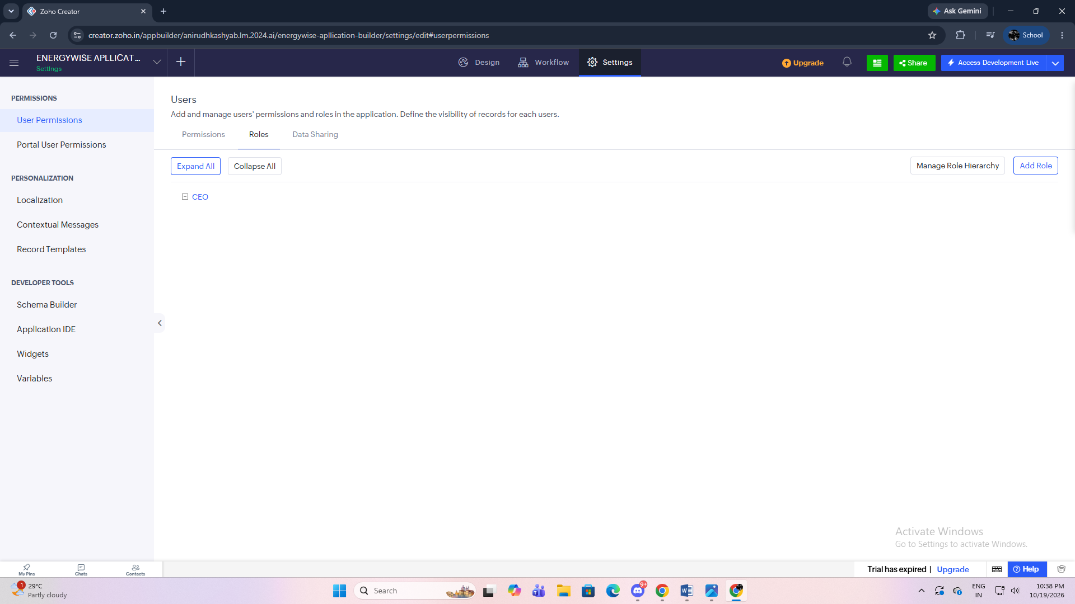Figure 5.8: Role and Permission Configuration (insert live screenshot)

5.9 AI and Analytics Features
Analytics can begin with charts, grouped reports and deterministic threshold rules. These are useful analytics but are not equivalent to a trained AI model. Zia or other AI-assisted features may be explored if they are enabled for the account and plan. A future version could use historical readings and contextual variables to forecast consumption or detect anomalies, with results validated against held-out data. No trained prediction model or Zia output is claimed unless captured from the actual application.

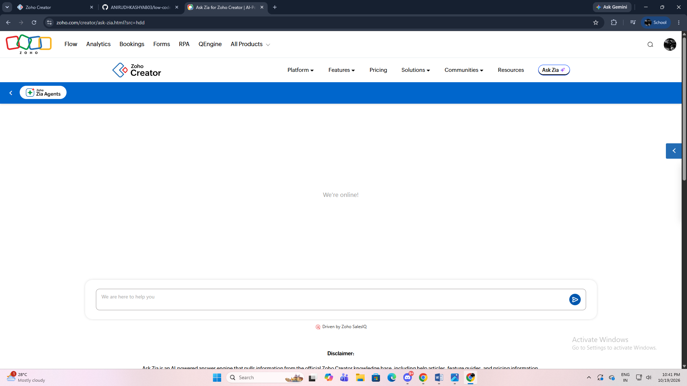
Figure 5.9: Energy Analytics / Zia Feature (only if available and tested)

5.10 Pro-Code Extension
Zoho Catalyst or another pro-code service is not required for the initial low-code prototype. The core needs—data entry, simple cost calculation, reports and threshold flags—can be addressed with Creator forms, reports and Deluge. Catalyst could be considered later if advanced processing, a custom API service or a separately hosted machine-learning model becomes necessary. This section is retained to explain the pro-code extension point; no Catalyst integration is claimed as implemented.
CHAPTER 6

TESTING AND DEBUGGING

6.1 Testing Strategy
Testing should be performed at form, workflow, report, permission and end-to-end levels. Positive tests verify that valid building and energy records can be saved. Negative tests check missing required fields and negative numeric values. Calculation tests compare expected and actual cost. Report tests verify filtering and grouping. Permission tests use separate authorised accounts where available. API and deployment tests apply only if those components are configured. Record actual outcomes in Table 6.1 after running the tests.

6.2 Test Cases
Table 6.1: Test Cases
TC ID | FR Ref. | Test Description | Input / Steps | Expected Result | Actual Result | Status
TC-01 | FR-01 | Submit valid building | Enter BLD001, REC Main Block, Chennai, 4 floors, 5000 m² | Building record is saved | Record after live test | To execute
TC-02 | FR-01 | Omit building name | Leave Building Name blank and submit | Required-field validation appears | Record after live test | To execute
TC-03 | FR-02 | Submit valid reading | Building BLD001, 120 kWh, ₹8/kWh | Reading is saved and linked to building | Record after live test | To execute
TC-04 | FR-02 | Omit reading date | Leave Reading Date blank | Validation prevents invalid record | Record after live test | To execute
TC-05 | FR-02 | Enter negative kWh | Enter -10 kWh | Negative value is rejected or flagged | Record after live test | To execute
TC-06 | FR-03 | Check cost calculation | 120 kWh at ₹8/kWh | Expected cost is ₹960 | Record after live test | To execute
TC-07 | FR-03 | Check zero consumption | 0 kWh at ₹8/kWh | Expected cost is ₹0 | Record after live test | To execute
TC-08 | FR-03 | Check decimal input | 12.5 kWh at ₹8/kWh | Expected cost is ₹100 | Record after live test | To execute
TC-09 | FR-04 | Reading exceeds threshold | Enter 150 kWh with threshold 100 | Review flag/message appears if configured | Record after live test | To execute
TC-10 | FR-04 | Reading below threshold | Enter 50 kWh with threshold 100 | No high-usage flag | Record after live test | To execute
TC-11 | FR-05 | Filter by building | Select BLD001 in report filter | Only matching records appear | Record after live test | To execute
TC-12 | FR-05 | Sort by date | Sort readings newest first | Dates appear in descending order | Record after live test | To execute
TC-13 | FR-05 | Dashboard totals | Use known sample records | Displayed totals match the records | Record after live test | To execute
TC-14 | FR-06 | Viewer attempts edit | Sign in as Viewer and open a record | Edit is unavailable if permissions are configured | Record after live test | To execute
TC-15 | FR-06 | Unauthorised report access | Attempt to open a restricted report | Access is denied if configured | Record after live test | To execute
TC-16 | FR-07 | API import (optional) | Send an authorised test request | Valid reading is imported only if integration exists | Record after live test | Not applicable until integrated
TC-17 | FR-08 | Filter by date range | Select start/end date | Only records in the range appear | Record after live test | To execute

6.3 Debugging Deluge Scripts
Use the Creator form validation messages, Deluge editor diagnostics, workflow execution details and temporary info statements to locate errors. Verify field link names, data types and event triggers before running a script. A representative issue to check is a mismatch between a display label and its actual Deluge link name. Record a bug as encountered only if it occurred during testing; otherwise use the defect log to document issues found during the real test run.

6.4 Defect Log
Table 6.2: Defect Log
Bug ID | Description | Root Cause | Fix Applied | Status
BUG-01 | To be completed from actual testing | Record actual observed cause | Record actual fix and retest result | Open / N.A. until tested
BUG-02 | Do not invent defects; add only issues encountered | — | — | N.A. until tested

6.5 User Acceptance Testing
Table 6.3: User Acceptance Feedback
User | Role Tested | Feedback | Action Taken
Tester 1 (name only with permission) | Energy Manager | Collect feedback after a real demonstration | Record actual feedback; do not pre-fill as if collected
Tester 2 (name only with permission) | Viewer | Collect feedback after a real demonstration | Record actual feedback; do not pre-fill as if collected
CHAPTER 7

DEPLOYMENT, SECURITY AND GOVERNANCE

7.1 Environments and Deployment Strategy
Use the development application for configuration and initial tests. If the account supports separate stage and production environments, validate changes in the stage environment before publishing. If those environments are not available, document the actual single-environment workflow instead of claiming a staged deployment. Keep a change log, export or backup where supported, and a rollback plan before making production changes. Deployment date and live URL must be recorded only after a successful deployment. If the account supports separate stage and production environments, validate changes in the stage environment before publishing. The exact audit trail, backup and licence-management controls depend on the Creator plan and account settings.

Table 7.1: Deployment Checklist
S.No. | Checklist Item | Done (✓)
1 | All test cases executed in Development / Stage | Pending actual test
2 | Sample/test data removed or isolated | Verify before deployment
3 | Permissions checked using appropriate accounts | Pending actual test
4 | Workflow outputs verified against expected values | Pending actual test
5 | Backup/export and rollback plan reviewed | Verify available options
6 | Live URL and deployment date recorded | Pending deployment
7 | Version / release notes recorded | Not used / verify

7.2: Performance Optimisation Results
Optimisation Applied | Component | Before | After | Improvement
Filter report by building/date | Energy Readings Report | All readings shown | Only matching records shown | Reduces irrelevant rows; measure actual load time
Limit unnecessary columns | Energy Readings Report | All available columns | Only required columns | Improves readability; quantify only if measured
Avoid repeated lookups in loops | Deluge workflow, if implemented | Repeated retrieval could occur | Retrieve required data efficiently | Apply only if relevant script exists

7.3 Security Features
Table 7.3: Security Controls Implemented
Security Control | Where Applied | Threat Mitigated
Role/profile permissions | Forms, reports and pages | Unauthorised editing or viewing
Required-field validation | Building Details and Energy Readings | Incomplete records
Secure connection for APIs | Future integration, if configured | Credential exposure and unauthorised API access
Credential redaction | Report screenshots and documentation | Accidental disclosure of secrets

7.4 Governance and Administration
Use consistent names for forms, reports, workflows and scripts; restrict editing to authorised users; avoid placing secrets in code or screenshots; and review available audit and change-history features. Export or back up application configuration and data using supported options before major changes. Review users and permissions periodically. The exact audit trail, backup and licence-management controls depend on the Creator plan and account settings.

CHAPTER 8

RESULTS AND DISCUSSION

8.1 Application Output
Scenario: an authorised operator selects a registered building, enters the reading date, equipment type, energy consumed and tariff, and submits the record. The application validates required fields, calculates estimated cost if the workflow is configured, and saves the reading. The Energy Manager reviews the reading report and dashboard, then investigates any reading flagged by the threshold rule. The scenario should be demonstrated with a real saved record and screenshots before being reported as passed.

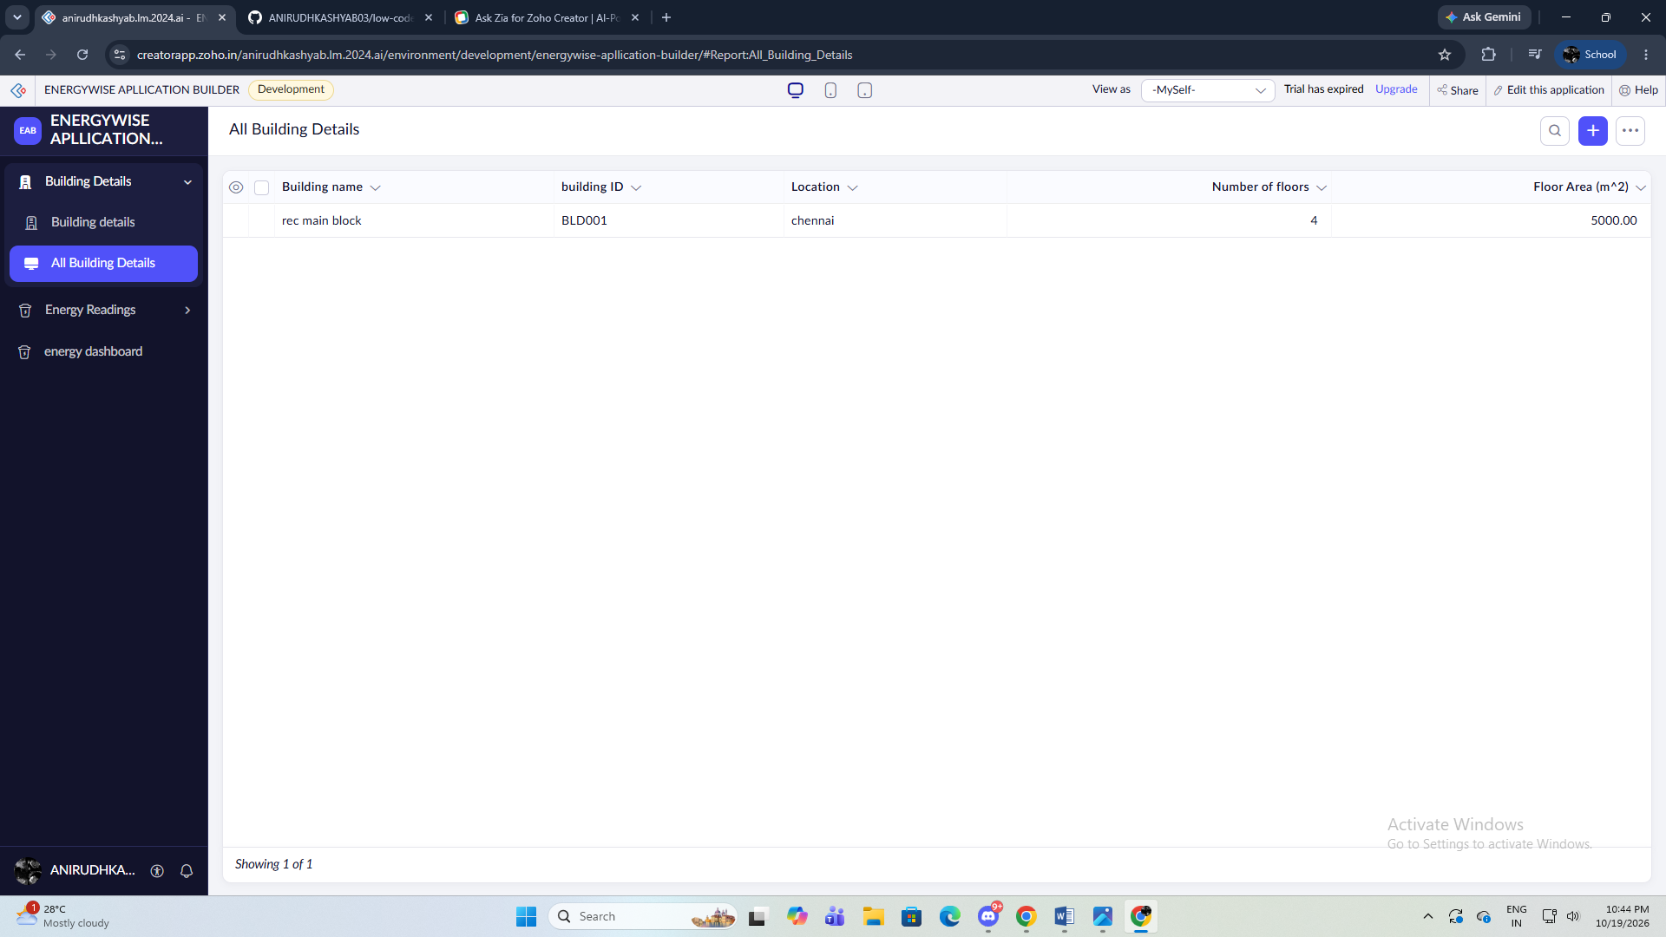
Figure 8.1: Scenario Step 1 – Register Building
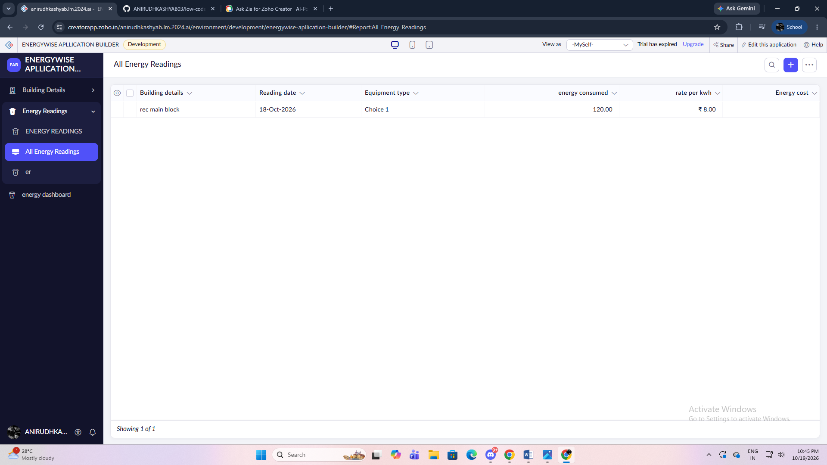

8.2 Achievement of Objectives
Table 8.1: Mapping of Objectives to Outcomes
Objective (Sec. 1.3) | Implemented Through | Outcome / Evidence
Centralise building and energy data | Building Details and Energy Readings forms | Verify saved records and screenshots
Calculate estimated energy cost | DS-01 workflow/formula | Expected test: 120 × ₹8 = ₹960; verify live result
Display consumption information | Reports and Energy Dashboard | Verify report and chart screenshots
Identify unusually high readings | Threshold rule / review flag | Verify only if workflow is implemented
Protect application records | Role and permission configuration | Verify with actual role tests
Explore extensibility | API / Catalyst design | Proposed only unless integration is implemented

8.3 Comparison with the Existing System
Table 8.2: Existing System versus Proposed Application
Parameter | Existing / manual process (assumed baseline) | Proposed application | Improvement
Time to process one reading | Manual entry and calculation; baseline not measured | Form entry and automatic calculation if configured | Measure both times during testing
Manual steps | Separate entry, calculation and summary steps | Centralised record and report workflow | Count steps during actual test
Visibility of high usage | Depends on manual review | Threshold flag if configured | Verify using test records
Data consistency | Depends on spreadsheet discipline | Required fields and typed inputs | Verify validation behavior

8.4 Limitations of the Low-Code Approach
Potential limitations include plan-dependent feature availability, constraints in visual UI customisation, Deluge execution limits, API quotas, and the need for external services for real-time sensor ingestion or advanced machine learning. The practical workaround is to keep the first version focused on structured records, calculations and reports; use supported APIs for integrations; and introduce pro-code services only when a demonstrated requirement justifies the added complexity. These are potential constraints unless one was directly observed during implementation.

8.5 Reflection on the No-Code → Low-Code → Pro-Code Spectrum
EnergyWise sits across the no-code, low-code and pro-code spectrum. Form and report configuration are primarily no-code activities. Cost calculation and threshold rules are low-code tasks implemented with Deluge. Live sensor ingestion, advanced forecasting or specialised high-volume processing may require pro-code services. The appropriate choice depends on complexity, data volume, security requirements, maintenance capability and account limits.
CHAPTER 9

CONCLUSION AND FUTURE ENHANCEMENTS

9.1 Conclusion
EnergyWise provides a practical design for organising building information and energy readings in Zoho Creator. The proposed data model, reports, dashboard, cost calculation and threshold-based review process demonstrate how low-code features can support energy monitoring. The project should be considered complete only after the planned components are implemented, tested, and evidenced in the live application. Any advanced AI, API integration or production deployment should be reported according to what was actually configured.

9.2 Future Enhancements
- Predictive energy analytics using a validated model trained on historical readings and relevant building context.
- Integration with smart meters or a building-management system through a secure API for automatic reading ingestion.
- A pro-code microservice using Zoho Catalyst or another suitable platform for advanced anomaly detection and forecasting, if required.

9.3 Learning Outcomes and Career Relevance
The project connects low-code application development with data modelling, workflow automation, reporting, access control and integration design. These skills are relevant to low-code application development, business-process automation, application integration and solutions consulting. Future work can strengthen conventional programming, API security, testing, analytics and machine-learning evaluation so that low-code applications can be extended responsibly when requirements exceed built-in capabilities.

REFERENCES
[1] Zoho Corporation, “Zoho Creator Help Documentation.” [Online]. Available: https://www.zoho.com/creator/help/. Accessed: 19 Oct. 2026.
[2] Zoho Corporation, “Deluge Documentation.” [Online]. Available: https://www.zoho.com/deluge/. Accessed: 19 Oct. 2026.
[3] Zoho Corporation, “Zoho Catalyst Documentation.” [Online]. Available: https://catalyst.zoho.com/help/. Accessed: 19 Oct. 2026.
[4] International Organization for Standardization, “ISO 50001:2018 Energy management systems.” Geneva, Switzerland: ISO, 2018.
[5] U.S. Department of Energy, “Energy Saver: Energy Saving Tips for Buildings.” [Online]. Available: https://www.energy.gov/energysaver/energy-saver. Accessed: 19 Oct. 2026.

APPENDIX A – ZOHO CREATOR FEATURE COVERAGE CHECKLIST
Table A.1: Feature Coverage Checklist
Unit | Zoho Creator Feature | Done | Where in the Application | Report Section | Figure / Code No.
I | Application created & sections/menu organised | To verify | EnergyWise application | 5.1 | Fig. 5.1 (insert screenshot)
II | Forms with multiple field types | To verify | Building Details; Energy Readings | 5.2 | Fig. 5.2–5.3
II | Reports and charts | To verify | Building Register; Energy Readings Report | 5.3 | Fig. 5.4
II | Dashboard page | To verify | Energy Dashboard | 5.4 | Fig. 5.5
II | Deluge calculation | To verify | Energy Readings workflow | 5.5 | DS-01
II | Workflow automation | To verify | Energy cost / threshold workflow | 5.6 | Table 5.3
III | API integration | Not confirmed | No integration confirmed | 5.7 | Future extension
III | Role-based access | To verify | Application permissions | 5.8 | Fig. 5.8
III | Zia / AI feature | Not confirmed | No AI feature confirmed | 5.9 | Future extension
V | Zoho Catalyst / pro-code extension | Not implemented in current evidence | Optional future service | 5.10 | Architecture proposal
IV | Deployment | Not confirmed | Enter actual environment and URL | 7.1 | Insert real deployment screenshot
II | Email / in-app notifications | To verify | Not used / verify | 5.5, 5.6 | Not used / verify
II | Form workflow | To verify | Not used / verify | 5.6 | Not used / verify
II | Scheduled workflow | To verify | Not used / verify | 5.6 | Not used / verify
II | Approval process | To verify | Not used / verify | 5.6 | Not used / verify
II | Blueprint | To verify | Not used / verify | 5.6 | Not used / verify
II | Batch / report workflow | To verify | Not used / verify | 5.6 | Not used / verify
II | Testing & debugging evidence | To verify | Not used / verify | 6 | Not used / verify
III | Integration with a Zoho service | To verify | Not used / verify | 5.7 | Not used / verify
III | Connection / REST API call (invokeurl) | To verify | Not used / verify | 5.7 | Not used / verify
III | Webhook or Creator REST API | To verify | Not used / verify | 5.7 | Not used / verify
III | Users, roles and permission profiles | To verify | Not used / verify | 5.8 | Not used / verify
III | Record-level access criteria / customer portal | To verify | Not used / verify | 5.8 | Not used / verify
III | Zia / AI feature | To verify | Not used / verify | 5.9 | Not used / verify
III | Analytics (charts / Zoho Analytics) | To verify | Not used / verify | 5.9 | Not used / verify
IV | Performance optimisation applied & measured | To verify | Not used / verify | 7.2 | Not used / verify
IV | Deployment across environments | To verify | Not used / verify | 7.1 | Not used / verify
IV | Security controls (encryption, OAuth, permissions) | To verify | Not used / verify | 7.3 | Not used / verify
IV | Governance (audit trail, administration) | To verify | Not used / verify | 7.4 | Not used / verify
V | Pro-code extension (Catalyst / widgets / custom functions) | To verify | Not used / verify | 5.10 | Not used / verify
V | Low-code limitations & spectrum analysis | To verify | Not used / verify | 8.4, 8.5 | Not used / verify
— | Mobile app / portal access | To verify | Not used / verify | 5.11 | Not used / verify

Total features implemented: to be counted honestly after verifying the live application / 32

APPENDIX B – COURSE OUTCOME MAPPING
Table B.1: Mapping of Course Outcomes to Report Chapters
CO | Course Outcome Statement | Evidenced In | Self-Assessed Level | Examiner Level
CO1 | Explain the principles, architecture, and business value of low-code application development using Zoho Creator. | Ch. 1, 2 | 2 – Medium
CO2 | Develop business applications using Zoho Creator forms, reports, workflows, and Deluge scripting. | Ch. 4, 5, 6; verify live evidence | 2 – Medium (update after implementation)
CO3 | Apply data modelling and UI design to a business application. | Ch. 3, 4, 5 | 2 – Medium
CO4 | Apply integration, user management, analytics and security concepts. | Ch. 5, 7 | 1 – Low until features are verified
CO5 | Evaluate low-code limitations and future pro-code extension options. | Ch. 8, 9; Appendices | 2 – Medium

APPENDIX C – COMPLETE DELUGE SOURCE CODE
C.1 Energy Readings – Energy Cost Calculation (illustrative; verify before use)
// Script ID : DS-01
// Location : Energy Readings workflow (configure actual event)
// Purpose : Calculate estimated energy cost
// IMPORTANT: Confirm field link names and field types in the live app.
input.Energy_Cost = input.Energy_Consumed * input.Rate_per_kWh;

C.2 Energy Readings – Threshold Flag (optional; enable only after configuration)
// Script ID : DS-02 (optional)
// Location : Energy Readings workflow after required fields are validated
// Purpose : Flag a reading above a configurable threshold
// Create Review_Flag as a Decision Box/Boolean field before using this example.
// if(input.Energy_Consumed > 100)
// {
// input.Review_Flag = true;
// }
// The threshold is illustrative and should be calibrated to the building.

APPENDIX D – USER MANUAL

D.1 Accessing the Application
1. Open the organisation's authorised Zoho Creator URL in a supported browser and sign in using the assigned account. 2. Open EnergyWise from the Applications page. 3. Use the application menu to open Building Details, Energy Readings, reports or the dashboard. 4. Mobile use is optional and should be documented only if the app has been tested in the Zoho Creator mobile app.

D.2 Instructions for Administrator
- Open the relevant EnergyWise form or report from the application menu.
- Enter or review only the records permitted for the assigned role, then save or exit the screen.

D.3 Instructions for Energy Manager
- Open the relevant EnergyWise form or report from the application menu.
- Enter or review only the records permitted for the assigned role, then save or exit the screen.

APPENDIX E – EVALUATION RUBRIC
(For Examiner Use Only)
Student Name | L. M. ANIRUDH KASHYAB | Register No. | 241501020
Project Title | ENERGYWISE – AI BUILDING ENERGY OPTIMIZATION | Date | 19 October 2026

Table E.1: Evaluation Rubric for the Individual Project
S.No. | Criterion | Indicators | Max. Marks | Marks Awarded
1 | Problem Definition & Requirement Analysis | Clarity of problem, measurable objectives, complete FR/NFR, use cases | 10
2 | System Design | Architecture, ER/data model, form specifications, workflow design, permission matrix | 10
3 | Forms, Reports & Pages | Variety of field types, lookups/subforms, report types, UI Builder dashboards | 15
4 | Deluge Scripting & Workflows | Correctness and depth of scripts; form, schedule, approval, Blueprint, batch workflows | 15
5 | Integration, RBAC & AI | Zoho/external integrations, connections, roles & permissions, Zia/analytics | 10
6 | Testing, Deployment, Security & Governance | Test coverage, environments, optimisation, security controls, audit | 10
7 | Live Demonstration | End-to-end working of the application across roles; feature checklist verified | 15
8 | Project Report | Adherence to template and format, clarity, figures, references | 5
9 | Viva-Voce | Understanding of the platform, design decisions and low-code concepts | 10
 | TOTAL |  | 100

Table E.2: Performance Level Descriptors
Level | % of Max. Marks | Descriptor
Excellent | 90–100 | Feature implemented completely, correctly and beyond the basic requirement; student explains design choices confidently.
Good | 70–89 | Feature implemented correctly with minor gaps; explanation adequate.
Satisfactory | 50–69 | Feature partially implemented or works only for the main path; limited explanation.
Needs Improvement | < 50 | Feature missing, non-functional or not understood by the student.

Signature of Internal Examiner  Name: ____________________ | Signature of External Examiner  Name: ____________________

APPENDIX F – VIVA-VOCE RECORD SHEET
(For Examiner Use Only)
Student Name | L. M. ANIRUDH KASHYAB | Register No. | 241501020
Department / Section | Artificial Intelligence and Machine Learning | Date of Viva | To be filled
Application URL Verified | No – not confirmed | Demo Duration | To be filled
Table F.1: Viva-Voce Questions and Responses
Q.No. | Question / Topic Asked | Unit | Response (E / G / S / NI) | Remarks
1
2
3
4
5
6
7
8
E – Excellent G – Good S – Satisfactory NI – Needs Improvement
Table F.2: Marks Summary
Component | Max. Marks | Marks Awarded
Criteria 1–8 (Appendix E) | 90
Viva-Voce | 10
TOTAL | 100

Examiners’ Remarks:
____________________________________________________________________
____________________________________________________________________
INTERNAL EXAMINER  Name: ____________________ | EXTERNAL EXAMINER  Name: ____________________

